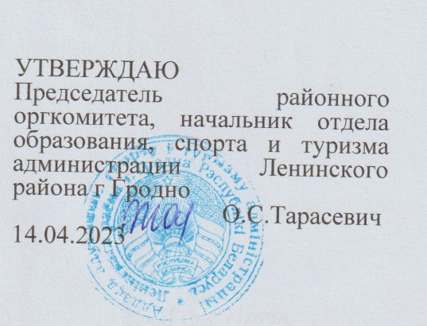

Situations for discussion 6th Form
1. Nobody knows you better than you yourself. Speak about yourself.
- What is your favourite thing to do at the weekend?
- What do you want to be when you get older? Why?
- What do you do when you get home from school?
- What do you like doing together with your parents?
- What is your hobby?
2. There are a lot of travel options. Why do people travel? Let’s talk about travelling.
- Have you ever been abroad? Where?
- What is your favourite means of transport?
- Is it important to plan a journey?
- What Belarusian sights would you like to visit? Why?
- Would you like to go on a safari?
3. Hobbies differ. Why do people need a hobby? Let’s talk about hobbies.
- Is sport a popular hobby? Why?
- Do your parents have hobbies? What hobbies do they have?
- What unusual hobbies do you know?
- Is it possible to live without hobby?
- What hobby would you like to take up?
4. Does school mean only lessons for you? Let’s talk about school.
- Do you have to wear a uniform to your school? Do you like wearing a uniform?
- Do you remember your first day at school?
- How much time do you spend on your homework?
- What do your classmates do during the breaks?
- What school rules do you have to follow?
5. There are certain things in life which you have to do whether you like it or not. One of such things is household chores, doing which is a necessity. Let’s talk about your household chores.
- Can you name some chores that need to be done every day?
- If you could buy only one of these two things, would you choose a dishwasher or a washing machine? Why?
- What is your favourite chore?
- What devices can be dangerous for children?
- How much time do you spend on household chores every day?

6. People can’t live without food. Do you agree? Let’s talk about food.
- Who cooks in your family?
- How many meals do you usually eat every day?
- How much do you eat when you are sad or happy?
- What is usually on your school menu?
- How often do you go to fast food restaurants?
7. Every country has its national dishes. What national dishes from your country would you recommend to the world? Let’s talk about Belarusian national cuisine.
- Do you think your country’s food is the best?
- Do you like shopping for food?
- What vegetable is the most popular in your country?
- Do you know any national dishes from other countries?
- What is your favourite Belarusian soup?
8. What attracts tourists to Belarus? Let’s talk about Belarus.
- What holidays do people celebrate in Belarus?
- What Belarusians museums can you recommend to visit?
- What countries would you like to visit?
- Are there any places of interest in your native town?
- What is the symbol of Belarus in your opinion?
9. Some people think that books make their life more interesting. Let’s talk about books and reading.
- How often do you go to the library?
- Is there a book that you have read more than once? What is the title? How many times did you read it?
- Do you read for pleasure or for knowledge?
- Do you prefer electronic or paper books? Why?
- Who reads a lot in your family?
10. Each of us can do something to help nature. Let’s talk about ecology and ecological problems.
- Why are the wild animals in danger?
- What are the main ecological problems?
- What endangered species of animals do you know?
- Do you agree that plastic pollution is a real threat to our planet?
- What can you personally do to help nature?

